LINE SMOOTHENING TOOL

This tool is an integrated part of the workflow to provide material boundaries while generating catchment Mesh, to delete the steep sharp angles between lines to produce a better quality mesh with less errors in elements that mostly occur near these sharp angle nodes.

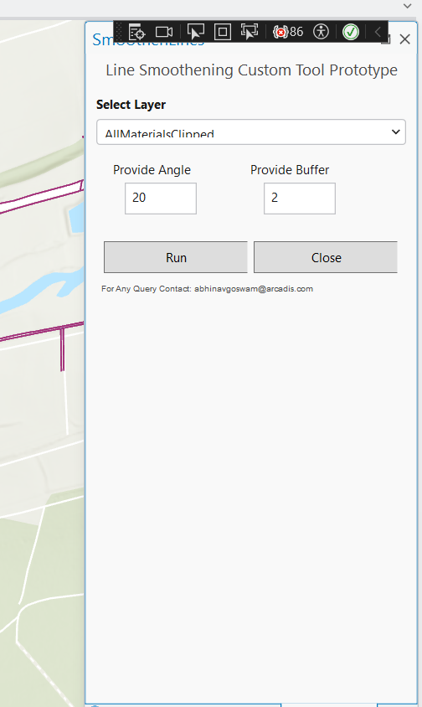
The tool will read the line layer calculate all the angles and will filter out the vertexes with angles less or equal to the threshold provided by the user, then will make an invisible circular buffer of the radius provided by the user and delete the parts of line lying within the circular buffer and if the line layer was dissolved it will explode it and then do the same. Then it will return the new line layer with all the vertexes with steep angles removed.
Provide threshold angle
Execute the command
Close
Provide buffer Value
Select the line layer from dropdown

